Name: _____________________________ Date: ____________

Global History I Mrs. Valdes

**Hinduism and Buddhism Review Sheet**

1. Hinduism developed from:

a. Siddhartha Gautama=Buddhism

b. one single founder (Buddhism, Christianity, Judaism, Islam)

c. Overlapping beliefs of the people from the Indus and Ganges River Valleys

d. Moses

2. Which river is most closely associated with Hinduism?

(a) Nile (Egypt) (c) Tigris (Mesopotamia)

(b) Yellow (China) (d) Ganges

3. A person who practices Hinduism would most likely:

a. believe the Vedas are sacred (Vedas=Holy Books)

b. worship in a synagogue (Judaism)

c. pray facing Mecca (Islam)

d. make a pilgrimage to Jerusalem

4. The **caste** system in India was characterized by?

a. toleration for various religious beliefs

b. equality between men and women

c. a lack of social mobility

d. the right of people to choose their occupations

5. Someone who travels attempting to convert someone to certain religion is called a ….?

a. missionary c. Disciple

b. apostle d. conqueror

6. Believers of Hinduism are expected to:

a. fulfill their dharma for a favorable reincarnation

b. complete a pilgrimage to Mecca

c. obey the Ten Commandments

d. follow the Eightfold Path to achieve enlightenment (Buddhism)

***Base your answer to questions #7 and #8 on the diagram below and on your knowledge of social studies.***

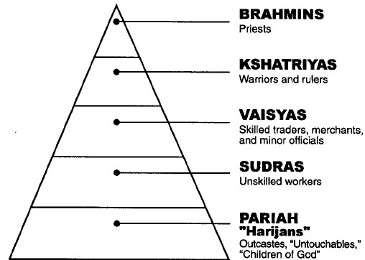

7. Which concept is illustrated in the diagram?

a. manorialism c. caste

b. food pyramid d. encomienda

8. Which religion or belief system is most closely associated with the social class system illustrated in the diagram?

a. Hinduism c. Catholicism

b. Daoism d. Islam

9. Which belief is **shared** by Hindus and Buddhists?

a. caste system c. monotheism

b. reincarnation d. Eight fold path

_____________________________________________________________________________

*Base your answer to question 10 on the quote below and on your knowledge of Global history.*

**“Just as a man, having cast off old garments (clothes), puts on others, even so does the embodied one, having cast off old bodies, take on other, new ones.”**

10. Which belief or practice is expressed in the above quotation?

a. rigid class structure c. monotheism (belief in one God)

b. fasting and prayer d. reincarnation

11. According to the Buddha, how does one eliminate suffering?

a. create better laws c. eliminate desire

b. wait for reincarnation d. offerings to Shiva (Hindu God)

12. The religious terms ***Four Noble Truths, Eightfold Path,* and *nirvana***are most closely associated with:

a. Judaism c. Shintoism

b. Islam d. Buddhism

13. The terms ***Brahman, dharma, and moksha*** are most closely associated with which religion?

a. Judaism c. Hinduism

b. Islam d. animism

14. **Siddhartha Gautama** was later known as…

1. Brahman c. Shiva
2. Buddha d. Vishnu

Base your answer to question 15 on the information below and on your knowledge of Global History.

1. **The way to end suffering is to eliminate desire (Buddhist)**
2. **All people have the opportunity to reach Nirvana (Buddhist)**
3. **Hindu caste system must be respected (Hindu)**
4. **Belief in many gods (Hindu)**

15. Which of the above are Buddhist teachings?

1. I and II c. None of these
2. I, II, III, and IV d. III and IV

_____________________________________________________________________________

16. Both Hindus and Buddhists believe in…

1. Reincarnation c. many gods
2. the caste system d. Allah

17. Which of the following traditions did Buddhists reject?

1. the caste system c. karma
2. nonviolence d. reincarnation

18. The priest class of Indian society were also known as the

1. Brahma c. untouchables
2. Brahmin d. Kshatriyas

19. The founder of Buddhism was…

1. Moses c. a group of Buddhists from India
2. Mohammed d. Siddhartha Gautama

20. Hinduism was founded by…

1. no one single founder c. Abraham
2. Siddhartha Gautama d. Mohammed

21. Which values are most closely associated with Buddhism?

1. competition and financial success
2. maintaining the caste system and providing education for all people
3. practicing non-violence and giving up worldly desires
4. self-determination and democracy

22. The term ***ahisma*** refers to

1. how a person lives their lives c. practice of non-violence
2. the rebirth of the soul (reincarnation) d. the Vedas (Holy Books of Hinduism)

23. Which term is used to describe the spread of Buddhism from India throughout Southeast Asia?

* 1. ethnocentrism
  2. cultural diffusion
  3. isolation
  4. imperialism

____________________________________________________________________________

**- Conquered northern India**

**- Established a bureaucracy**

**- Established a brutal secret police force to report on crime and corruption**

24. Which Indian emperor is described the statements above?

1. Siddhartha Gautama (founder of Buddhism) c. Confucius
2. Shi Huangdi (Ruler Qin Dynasty) d. Chandragupta Maurya

25. The ruler who converted to Buddhism and spread it throughout his empire was:

a. Chandragupta Maya c. Pericles

b. Asoka d. Augustus Caesar

26. Horrified at the slaughter from his bloody wars, Asoka converted to which religion?

1. Islam c. Christianity
2. Confucianism d. Buddhism

_________________________________________________________________________

• **Asoka incorporated Buddhist ideas into the laws he had carved on rocks and pillars placed throughout the Mauryan Empire.**

**• Constantine made Christianity the official religion of the Roman Empire.**

**• Prince Vladimir required all Russians to become Eastern Orthodox Christians.**

27. Which generalization can be made based on these statements?

a. Leaders often use religion to unify an empire.

b. Many political leaders encourage religious toleration.

c. Leaders sometimes use religion as a reason to wage war.

d. Political leaders usually become the head of the church in their country.

28. During the Gupta Empire, all aspects of society were based on the concepts and traditions of:

a. Buddhism c. Hinduism

b. Confucianism d. Judaism

___________________________________________________________________________

29. Which heading best completes the partial outline below?

|  |
| --- |
| I. ___________________________________________  A. Developed vaccines for smallpox a thousand years before Europe  B. Physicians (doctor) used herbs to cure illness  C. Indian Mathematicians developed the system of writing numerals  D. Indian Mathematicians developed the concept of zero |

a. Achievements of the Gupta Empire c. Life under Asoka Rule

b. Contributions of the Han Dynasty d. Achievements of Hinduism

30. In India, for which achievement is the Gupta Golden Age best known?

a. adoption of the printing press

b. invention of the iron foot stirrup

c. use of gunpowder

d. development of the concept of zero

Base your answer to question 31 on the passage below and on your knowledge of social studies.

… **Trade along the Silk Road enriched China in many ways. The Chinese sent silk, herbal**

**medicines, ceramics, and other local products westward by caravan, and received exotic things**

**in return. From Persia (modern-day Iran) and the Middle East, they received new kinds of musical instruments, and musicians to play them, as well as gold and silver cups, bowls, and vases. From India they imported cotton cloth. From Byzantium (the eastern capital of the Roman Empire, today the city of Istanbul in Turkey) came glassware and jewelry.** **Chinese merchants also traded some of these imported goods eastward to Korea and Japan.…**

—Des Forges and Major, *The Asian World: 600-1500*

31. Based on this passage, the Silk Road made it possible for the Chinese to import cotton cloth

from:

a. Persia c. Japan

b. the Roman Empire d. India

______________________________________________________________________________

**Base your answer to question32 on the map below and on your knowledge of social studies.**

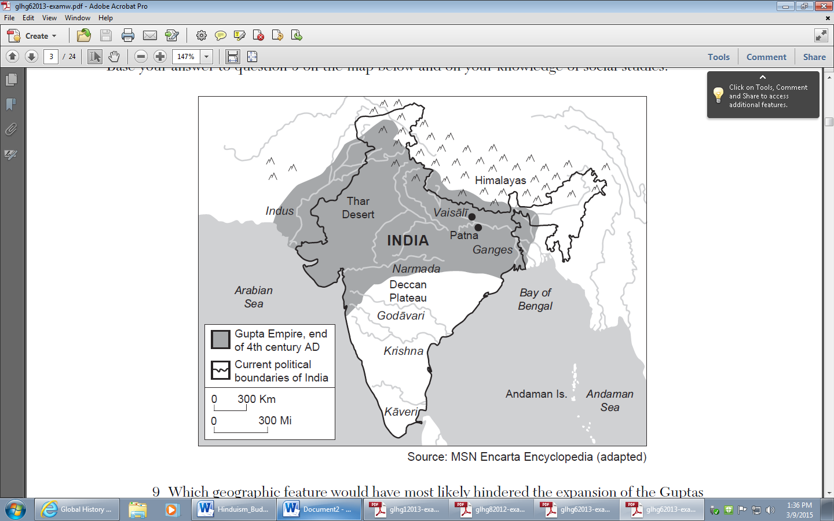

32. Which geographic feature would have most likely hindered the expansion of the Guptas

into what is modern-day China?

a. Thar Desert c. Himalaya Mountains

b. Deccan Plateau d. Bay of Bengal

_____________________________________________________________________________

Base your answer to question 33 on the outline below and on your knowledge of social studies.

|  |
| --- |
| **Golden Age of**  **I. Mathematical innovation**  **A. Decimal system**  **B. Concept of zero**  **II. Astronomy**  **III. Medicine**  **A. Vaccination**  **B. Plastic surgery**  **C. Hospital system**  **IV. Literature**  **A. Sanskrit poetry & fables**  **V. Art & Architecture**  **A. Stupas**  **B. Capital at Pataliputra**  **C. Ajanta Caves** |

33. Which civilization best completes the title of this outline?

a. Ghana c. Song

b. Khmer d. Gupta

**Part II**

**Directions: The following documents deal with Hinduism, Buddhism, and the Mauryan and Gupta Empires. Examine each of the documents carefully, and answer the questions that follow in complete sentences. Please use blue or black ink only.**

**Document #1:**  **The Hindu Caste System**



1. What is this picture a portrayal of (what does it show)? (1)

Caste System

2. Why were the “Untouchables” considered the outcasts of Hindu society? (1)

They are at the bottom on the Caste System. They have bad karma; they are not good enough to be part of the Caste System. They have jobs such as street sweepers, garbage men, and grave diggers.

**Document #2:**  **The Eightfold Path**

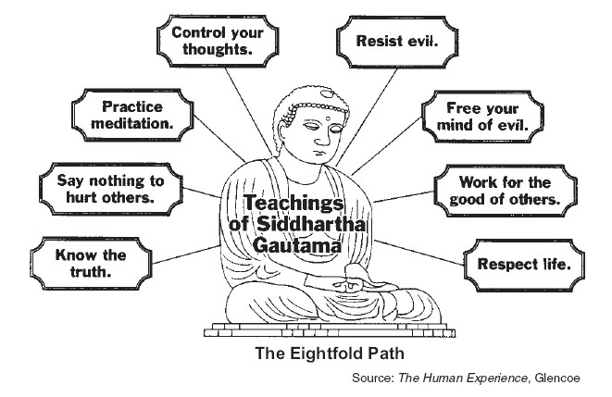

3. Which religion is depicted or shown in the above diagram? (1)

Buddhism

4. What are some reasons that Hindus would convert over to this religion? (2)

Buddhists do not have a Caste System, they believe everybody is equal.

5. Explain two other beliefs that are not mentioned in the diagram above. (4)

Reincarnation, good karma and dharma,

Four Nobel Truths: 1) All life is suffering 2) Desire causes suffering 3)Only way to end suffering is to stop wanting things 4)Follow the Eightfold Path to stop desiring things

**Document #3: Empires of Ancient India**

|  |  |  |
| --- | --- | --- |
|  | **Maurya Empire** | **Gupta Empire** |
| **Dates:** | 321 BC – 185 BC | AD 320 – 550 |
| **Location:** | Northern and southern India | Northern India |
| **Leaders:** | Chandragupta Maurya followed by his grandson Asoka |  |
| **Government:** | * Harsh Rule * Organized government * Officials collect taxes * Government owned factories | * Mild rule * Organized government * Villages and cities had power |
| **Religion:** | Hinduism / Buddhism | Hinduism |
| **Learning and Achievements:** | * Schools and libraries in the capital * Improved roads * Built hospitals * Missionaries spread Buddhism throughout southeast Asia | * Golden Age of Hindu Culture * Number system we use today * Invented the concept of zero * Decimal system * Plastic surgery * Smallpox vaccine * Carvings of gods and animals |

6. How was the Mauyra Empire rule different from the rule (government) of the Gupta Empire? (1)

Mauyran Empire had harsh rule and the Gupta had a mild rule.

7. Who was King Asoka and why did he convert to Buddhism? (2)

King Asoka was a ruler of the Mauyran Empire. He converted to Buddhism because he witnesses a very bloody battle where over 100,000 people were killed.

8. What is a “Golden Age”? (1)

A time to peace, prosperity, and achievements in math, art, literature, science, and architecture.

9. List three (3) accomplishments of King Asoka. (3)

Tolerant leader, respected other religions

Improved roads and built hospitals

Sent missionaries to spread Buddhism throughout Southeast Asia

10. List the Four Noble Truths of Buddhism: (4)

1. All life is suffering
2. Suffering is caused by desire or wanting things
3. Only way to end suffering is to end desire or stop wanting things
4. End desire by following the Eightfold Path